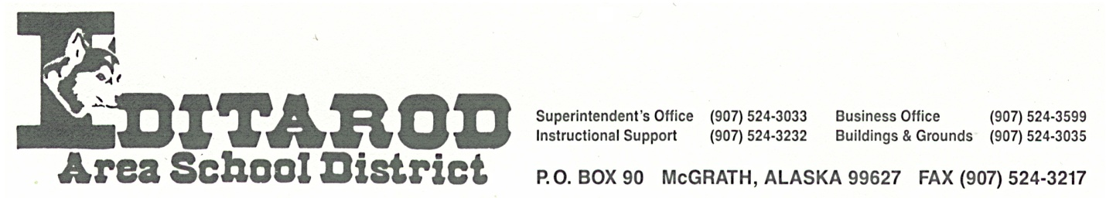

Superintendent’s Office (907) 524-1221

Business Office x1224 Maintenance x1231 or x1238

Special Education x1237 Federal Programs/Registrar x1226

**The Iditarod Area School District was formed July 1, 1976 under Alaska Statute, Title 14,**

**Chapter 8, Section 031 as a political subdivision of the State of Alaska thus being a non-**

**Profit, tax-exempt organization.**